**Name:Lakshmana Kumar Mettu**

**Class ID:11**

**Introduction:**This ICP is about to learn object oriented JavaScript along with jQuery.

**Programming Elements:** javascript2, jQuery, html5,css

**Tools Required:** Jetbrains-webstorm

**Objective-1:**Using JavaScript and jQuery to select a color by typing it in the text box or picking it from a given set of colors.

* I have developed normal html page for this ,shown below. 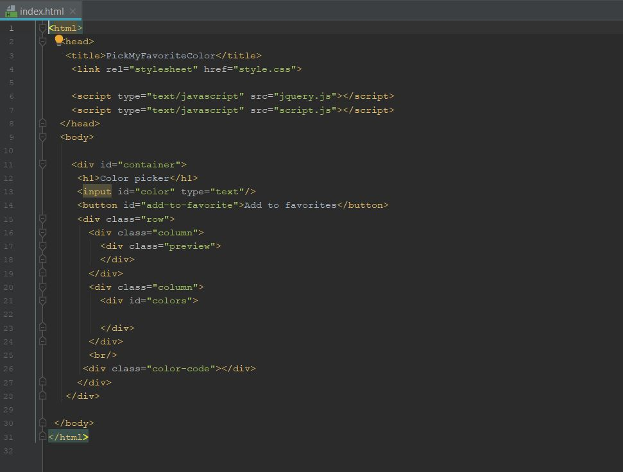
* The Javascript page for this one is given below.
* As the page loads add each color in the colors array to the div '#colors' Corresponding comments for each line is given in code snippets. 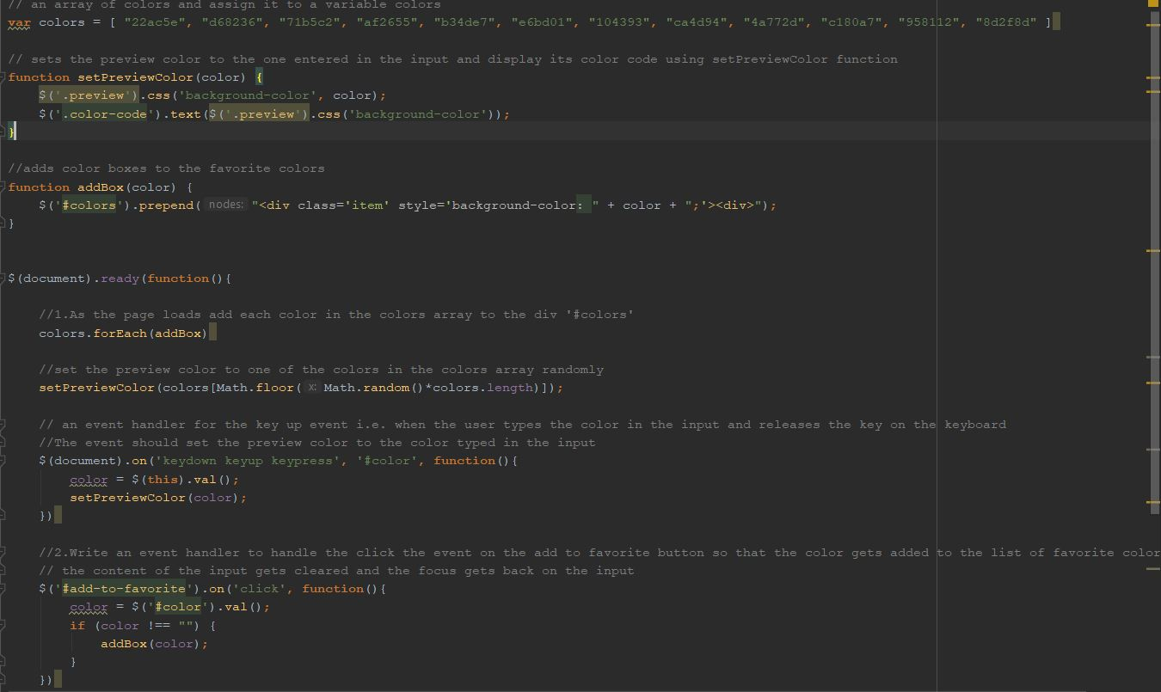

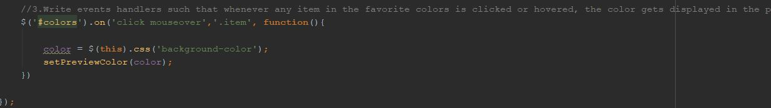

* The Jquery page to pick favorite color is given below. 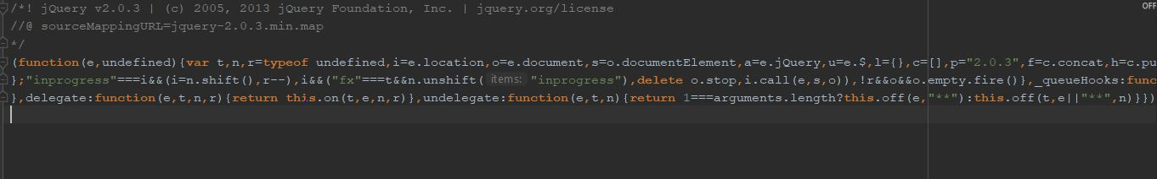
* Output image is given below. 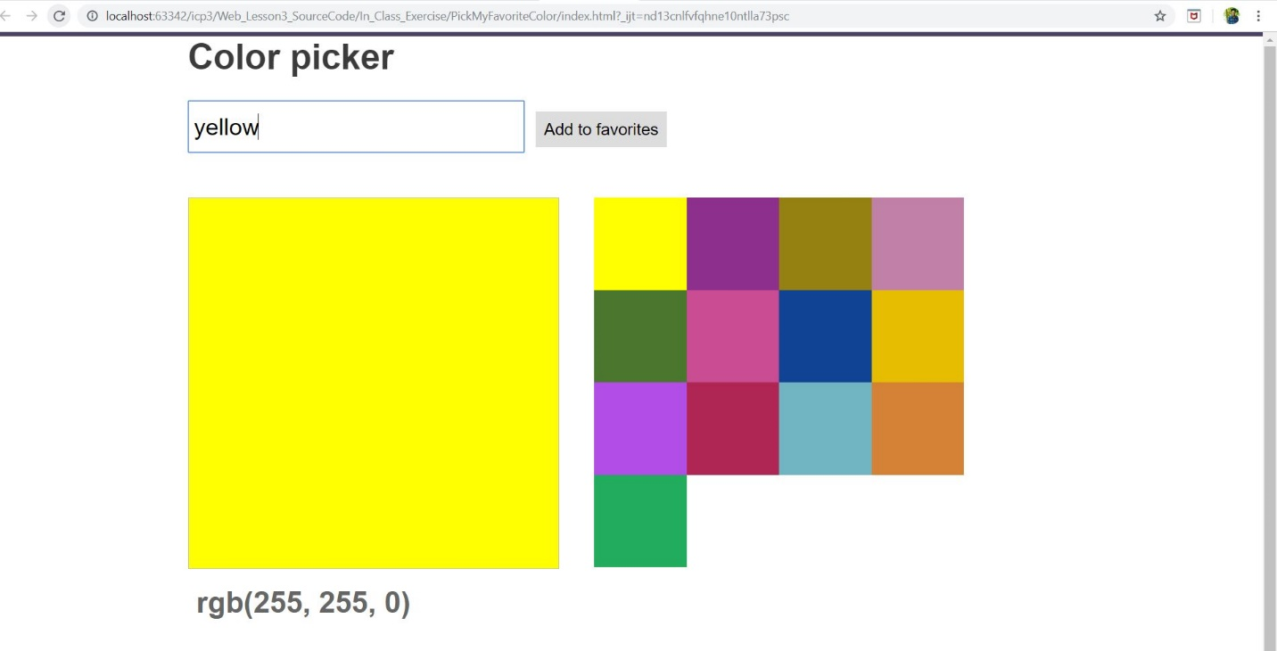

**Objective-2:To retrieve details of a GitHub user like the name, ID, profile picture and link to the user's account.**

* The HTML page for this one is given below. 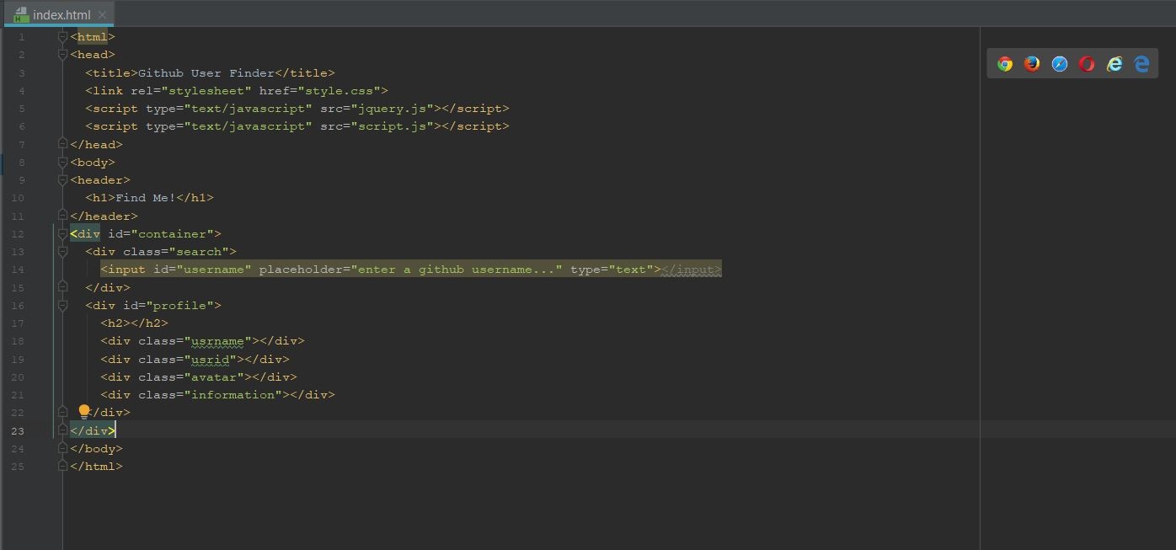
* The javascript page along with codesnippets and comments are shown below.

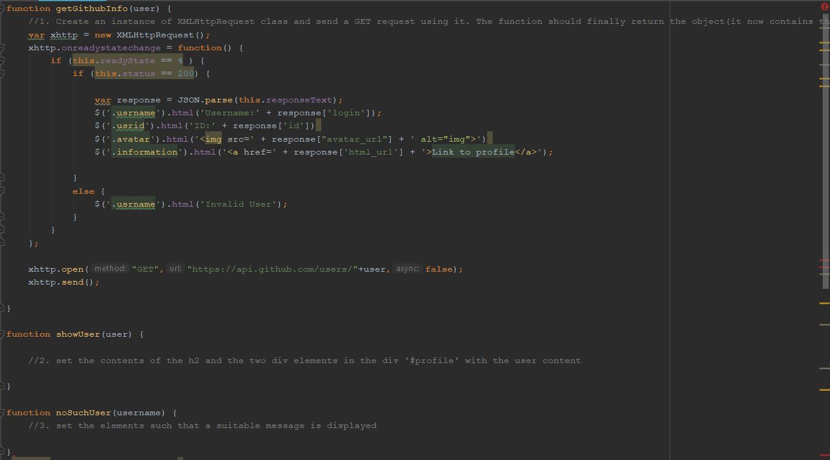

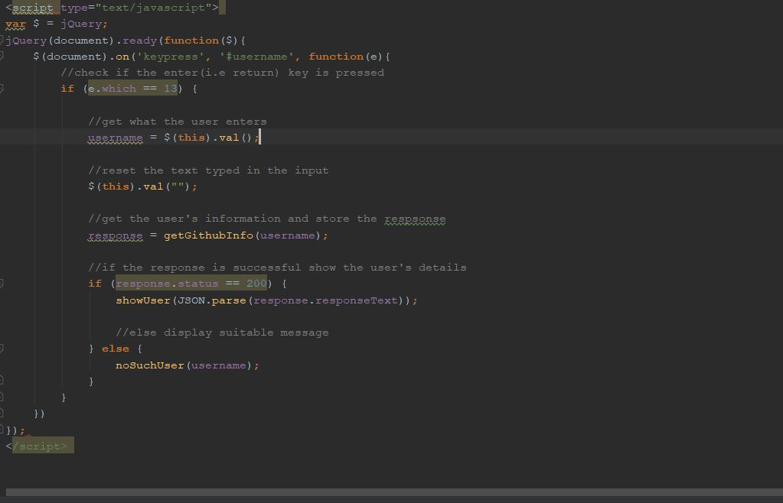

* The Jquery page is given below. 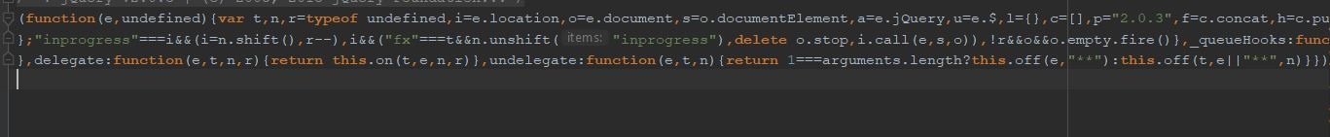
* Output: 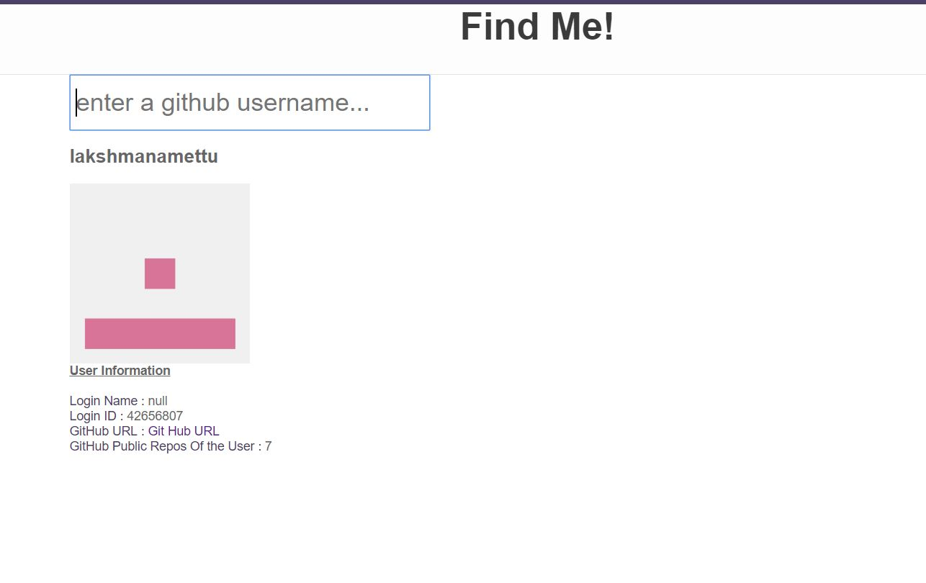

**Obejective-3:Using the To-do List use case and add a functionality of actions in form of the drop down and also add delete the item from list.**

* The html page for this given below. 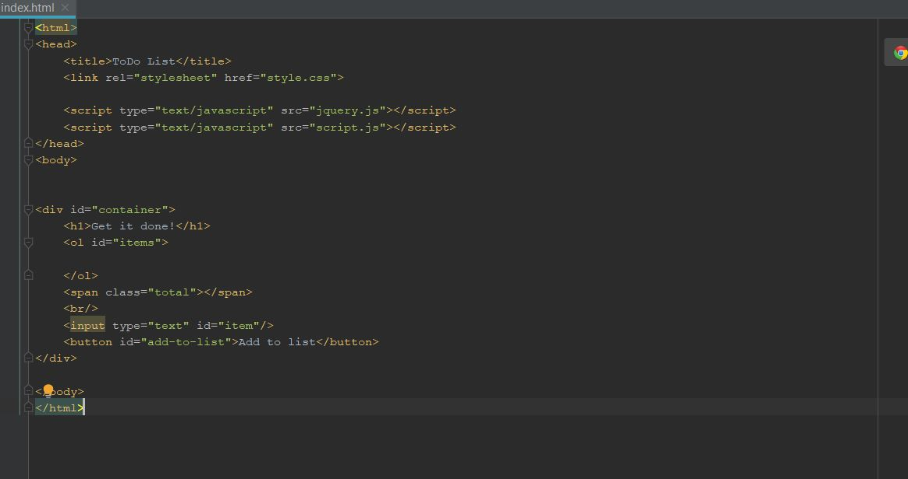
* Adding drop-down list and delete functionalities using java script are given along with comments.

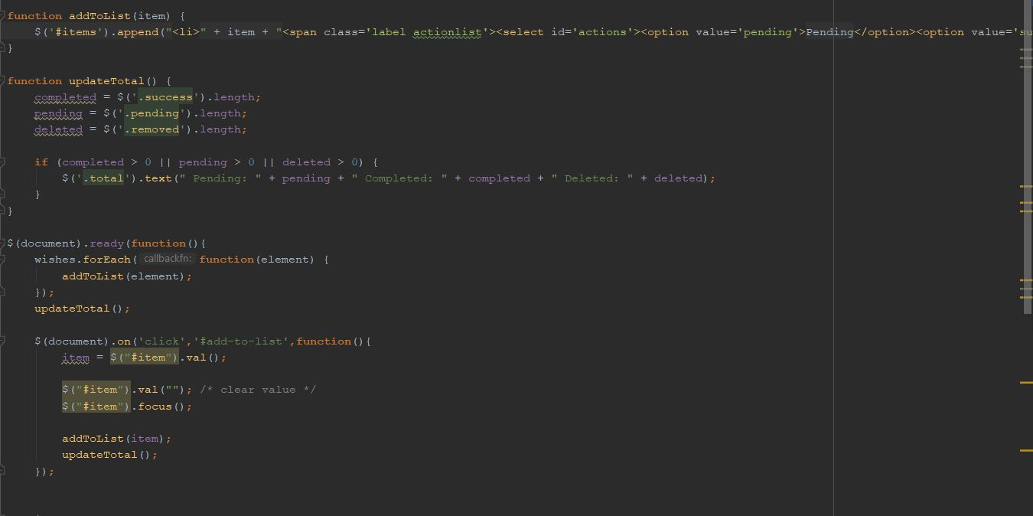

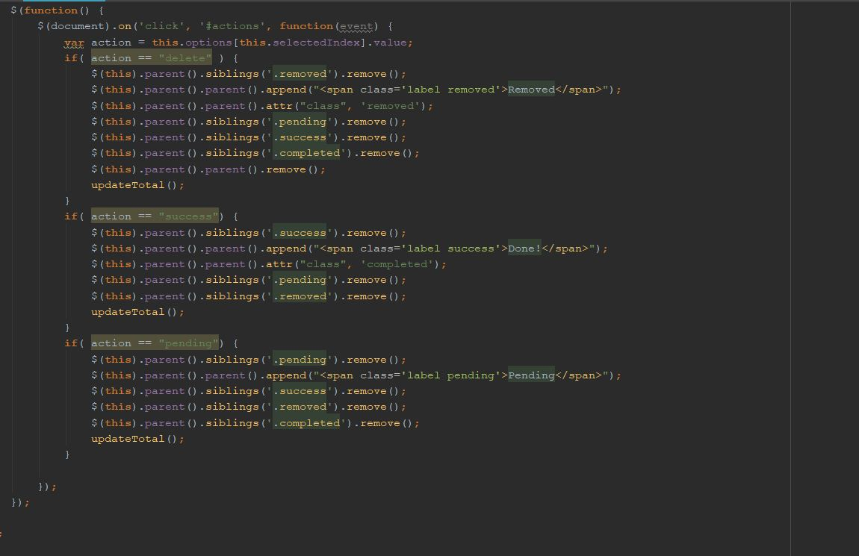

* The Jquery page for this task is given below. 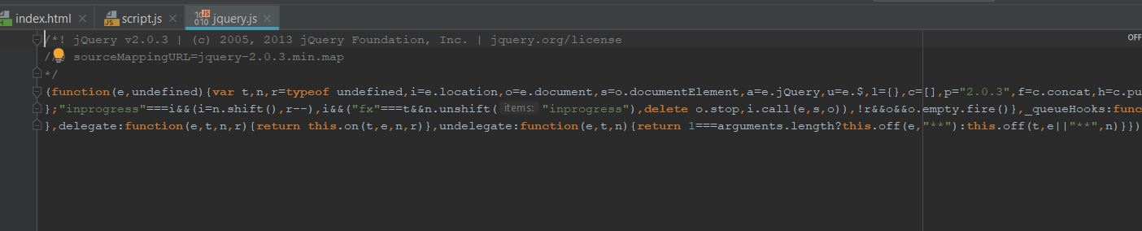
* Output:

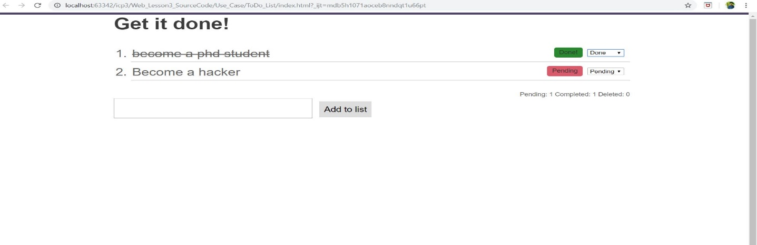

**Objective-4:Using Hangman use case to provide hint to the user in form of picture.**

* The html page for hangman.js is given here. 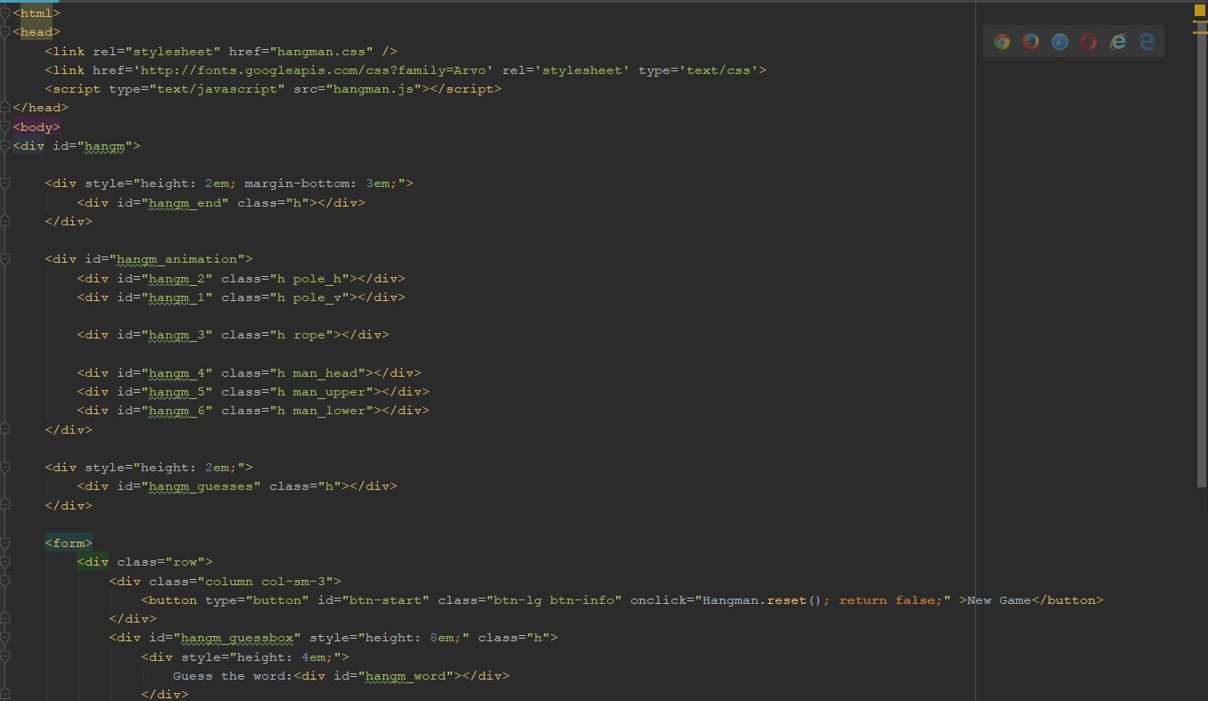

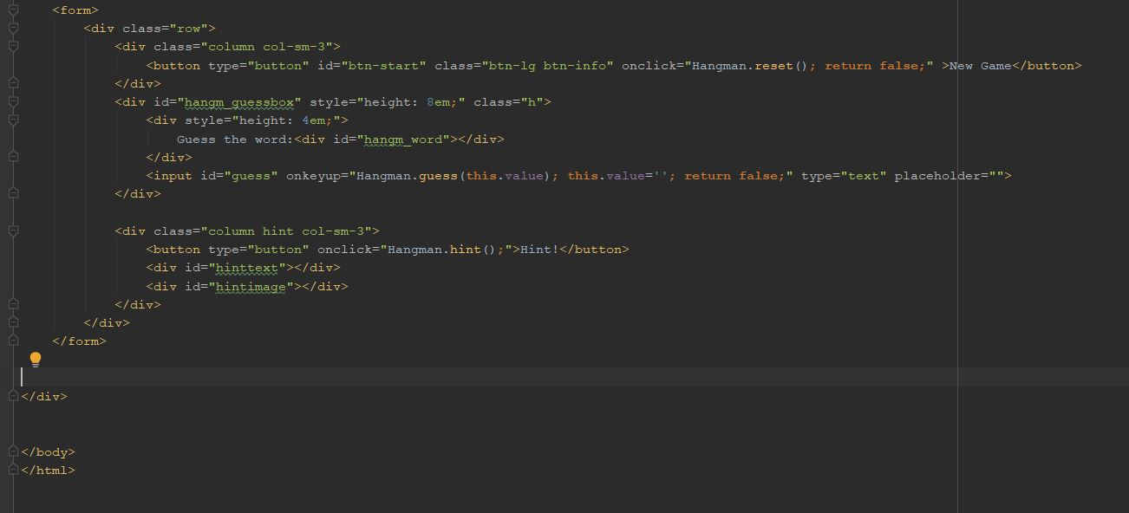

* Javascript page to provide hint in the form of picture for hangman.js are shown below along with comments 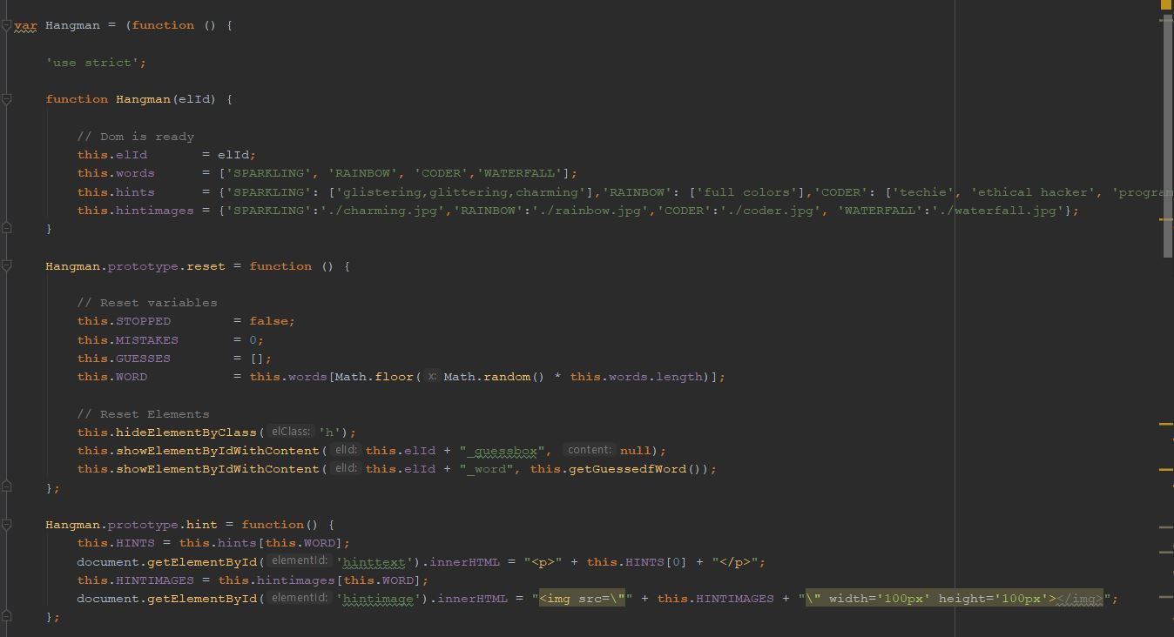

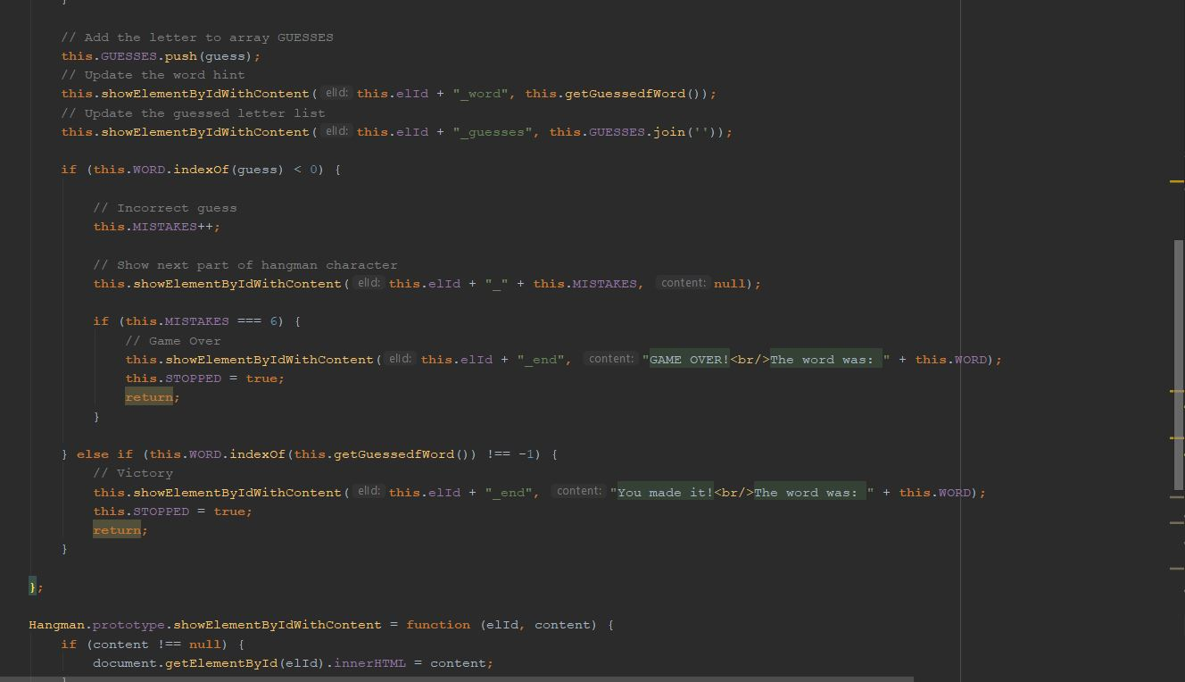

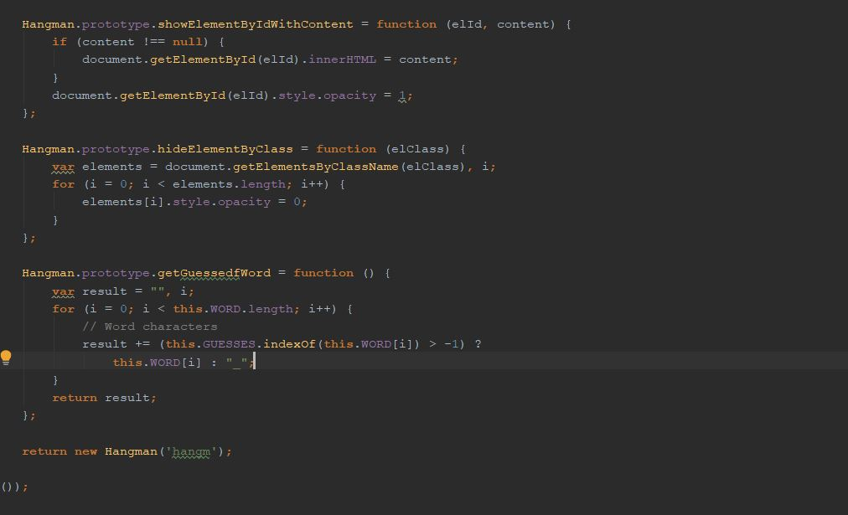

* Output for hangman.js: 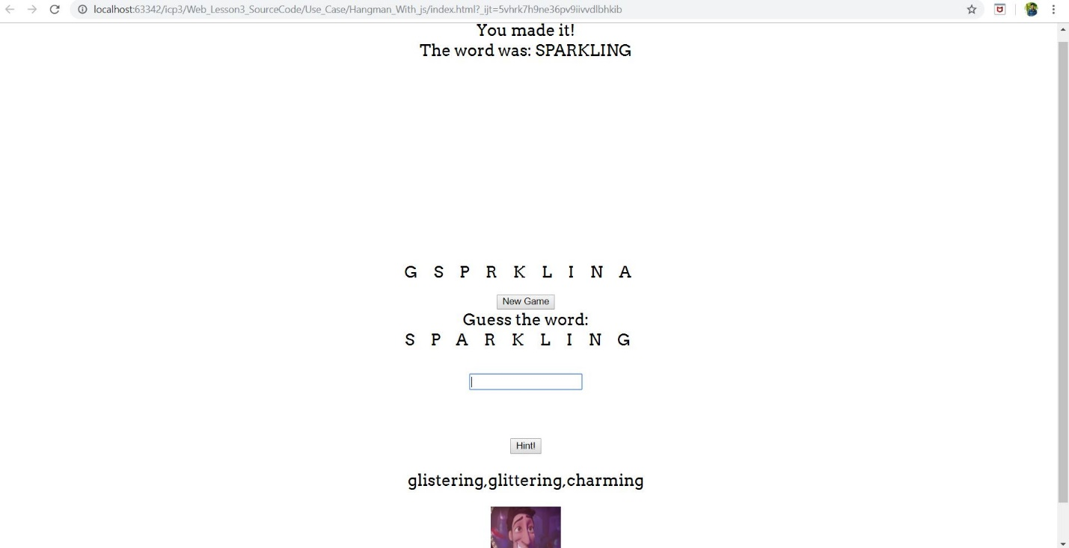

**Objective-4.1(Using Hangman API obtaining the given word):**

* The code snippets for hangman API using jquery,java script and html to provide word using hint shown .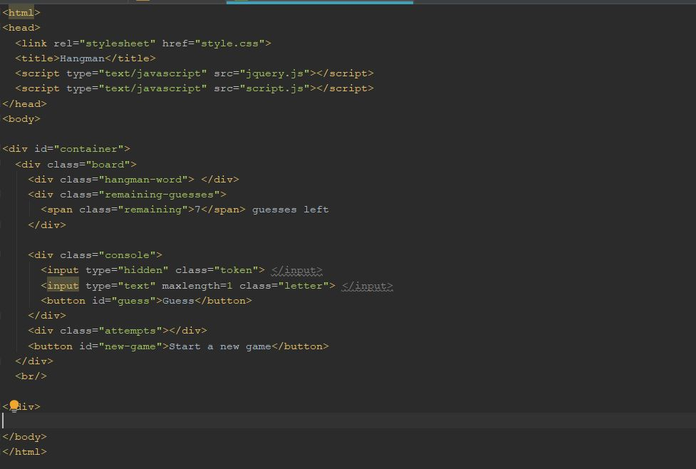

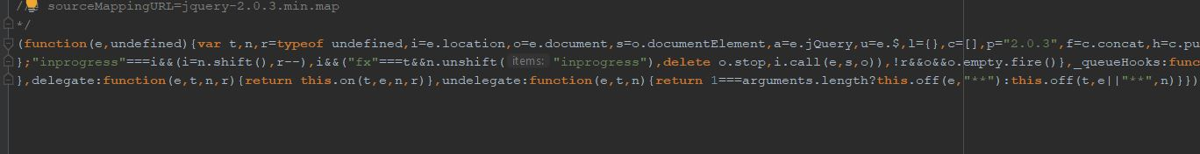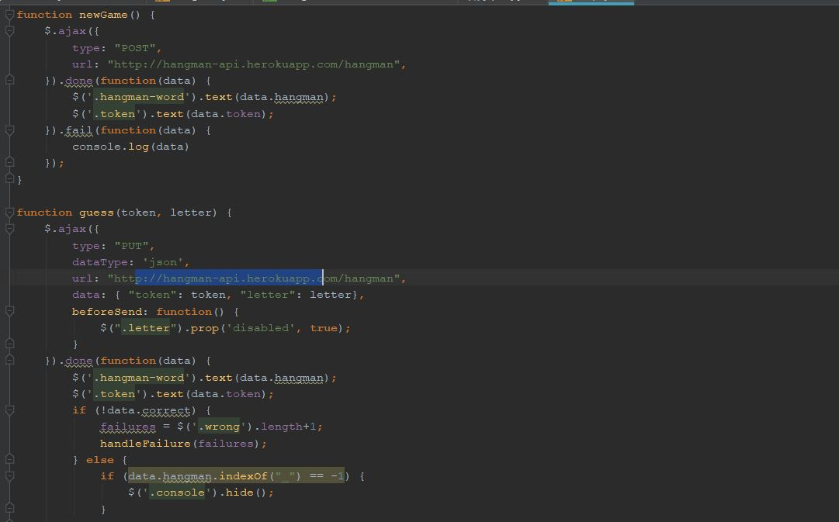

* Output for hangman API: 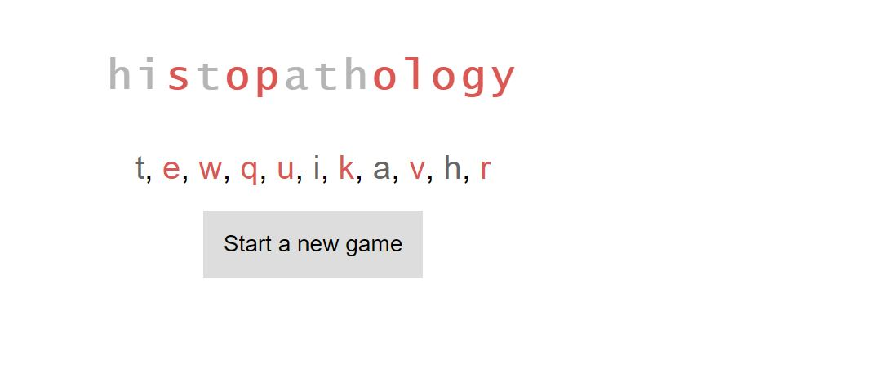

**Conclusion:**

* Hence I got insights about to develop web pages using jquery and java script.